**Open Shortest Path First (OSPF)**

**Instruction**

In this lab, we will implement the OSPF routing protocol. If you recall from the first IP Interfaces lab, only R1 has a direct interface outside of the network. Your goal is to configure each router to communicate with the Internet.

Part 1: Enable the OSPF daemon

Beginning with R1, edit /etc/frr/daemons to enable OSPF.

Restart frrouting by executing:

> systemctl restart frr

Repeat the steps in Part 1 in order to enable OSPF on R2, R3, and R4.

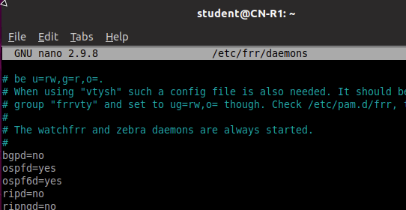

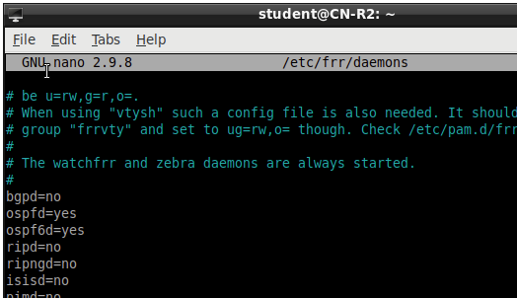

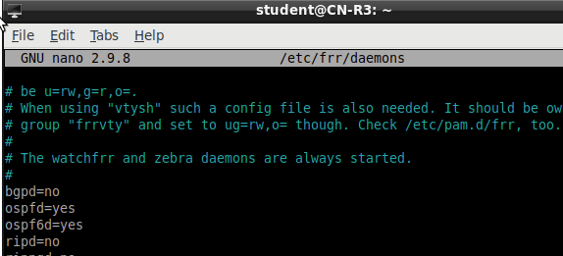 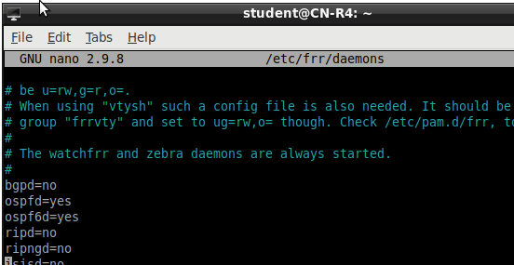

**Part 2:**

Now that we have enabled OSPF, we will need to use vtysh to configure R1 such that it advertises its

routable networks. In vtysh, execute the following commands:

> configure terminal

> router ospf

# specify the network(s) and areas advertised by R1 (use CIDR notation)

Hint: Run ifconfig and examine the interfaces to determine which network addresses to use.

For additional resources and configuration examples, consult the frrouting guide at:

<http://docs.frrouting.org/en/latest/ospfd.html#configuring-ospf>

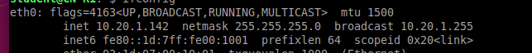

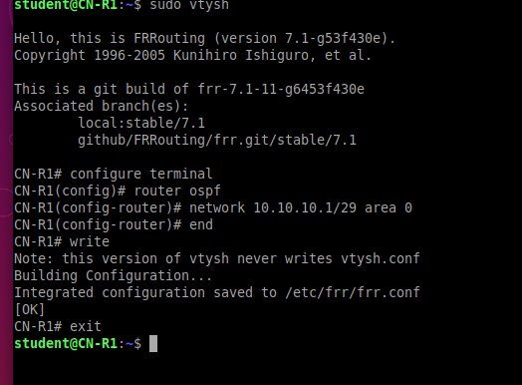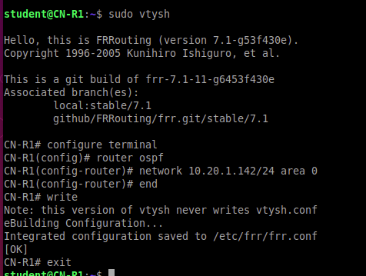

**Part 3:**

We will follow the same steps to configure each router in Area 1. *Please note that we will not run OSPF on R4 (eth2) since this interface points to a terminal node (see passive-interface).

**R2**

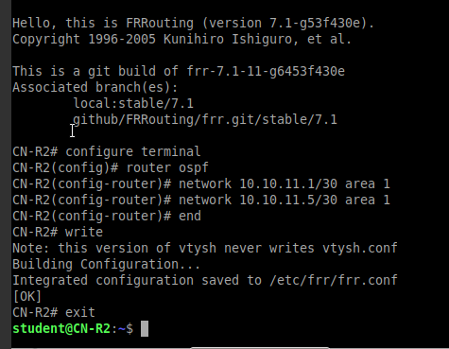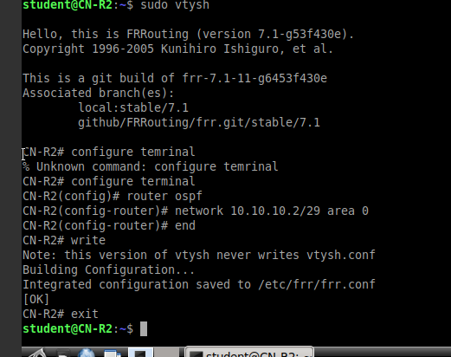

R3

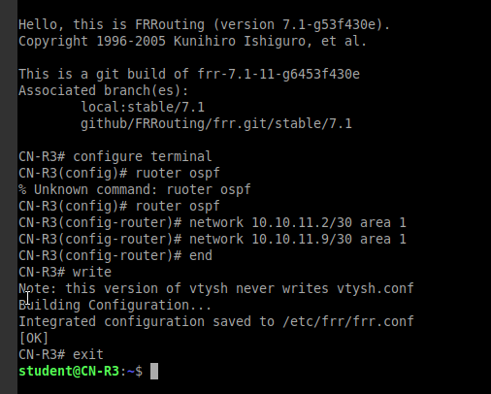

R4

* R4’s eth2 ip address will not be written into the ospf network because we’re not using that interface for the ospf layout.

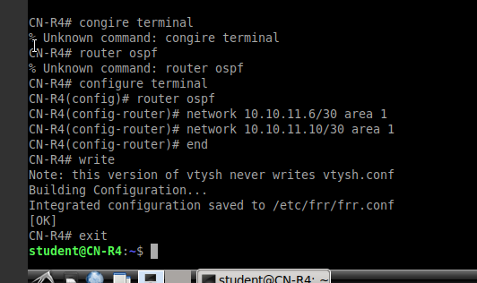

Disabling passive interface on R4 eth2

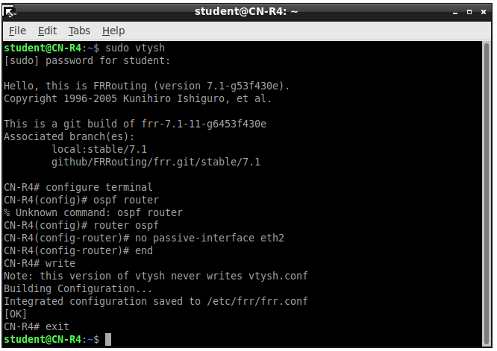

**Part 4**

The last step is to set the default IP route on R2, R3, and R4 so that they will go through R1 to access the Internet (i.e. all IP addresses outside of our network). You will have to browse through the FRR documentation to find the exact command.

You may verify that your configuration is correct by successfully pinging the SFTP server (128.238.77.36) from routers R2, R3, and R4

* The frrrouting command **default-informaiton originate always** forces the router to create a default ip address if there is no default route present. Putting this in R1 causes it to broadcast a default route to the network.
* An alternative is to assign the ip route of 0.0.0.0/0 to R1’s IP address of 10.10.10.1

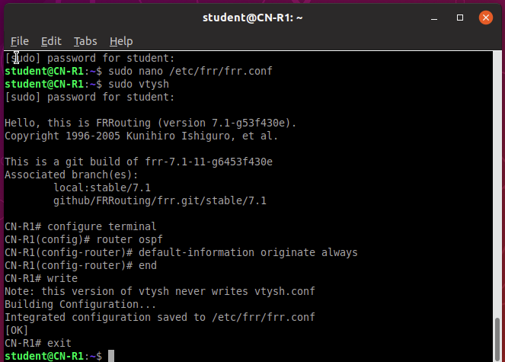

When sending these ping messages over the network, the packet sometimes gets lost in transmit.

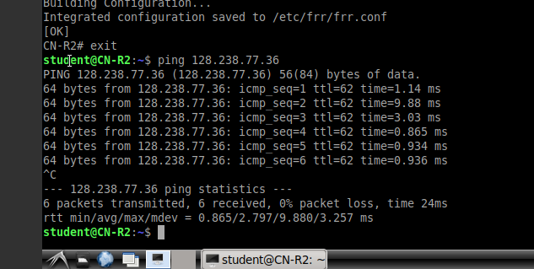

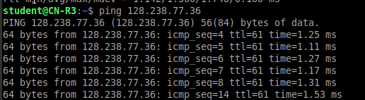

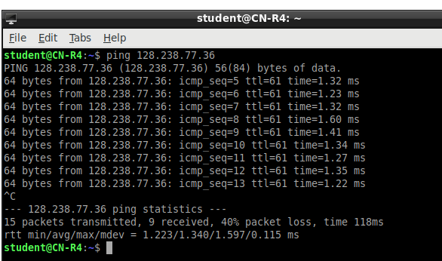

R2, R3, and R4’s default routes

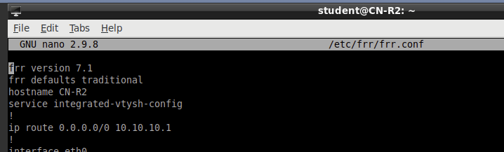

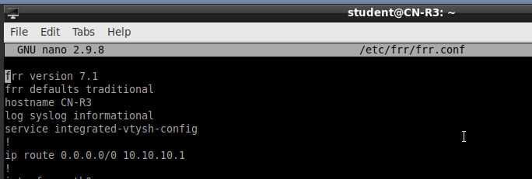

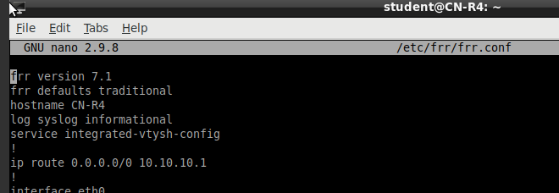

**Part 5: Questions**

1. Power on all routers and run Wireshark on R1. Apply a filter for OSPF and look at the Hello Packets. How frequently are these packets sent, and why must they be sent periodically?

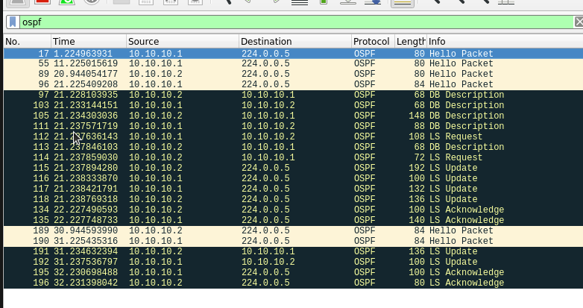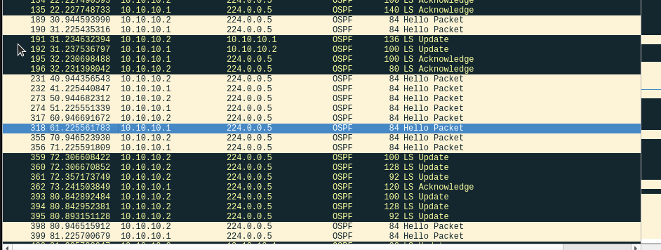



OSPF sends Hello packets at approximately 30-40 second intervals at the multicast IP address. This is to check what routers are still within the network. One router would send out a hello to all its neighbors and receive a reply if the neighbor sees the hello packet. If a router doesn’t hear a reply from a neighbor for a while, then it would notice that the router is down and broadcast the alert to the topology. This message has to be broadcasted periodically to keep track of what neighboring routers are still online.

1. Continue running Wireshark and turn off R4. You should now see new OSPF packet types captured on R1. Explain why Hello, Link State Update, and Link State Acknowledgements use the same Destination IP Address

R4 turned off at time 276, prompting an LS Update and an LS Acknowledge packet to be sent out throughout the OSPF network from R2. R2 detects R4 missing from the OSPF network after missed Hello packets and will send out an LS Update to its adjacencies. All Hello, LS Update, and LS Acknowledgements are sent towards the IP Address 224.0.0.5 which will get directed to R1 as well.

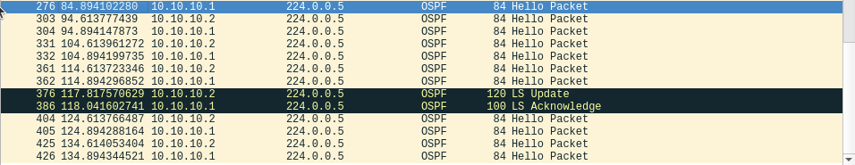

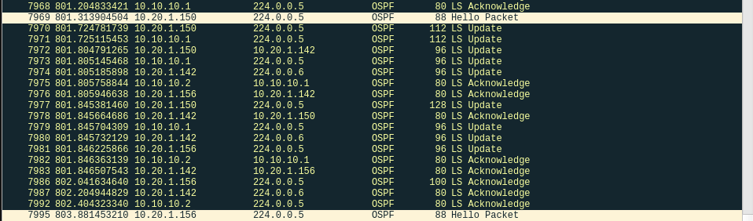

* The IP Address 224.0.0.5 is the multicast address of all OSPF routers. The router only needs to send the OSPF packets to this IP Address to send it to the rest of the adjacencies which share this multicast address. As a result, R1 only needs to communicate using 224.0.0.5 to communicate with the multicast.

1. Based on the above steps, explain why we do not see DB Descriptions and LS Requests on R1. Is there a situation in which we get all OSPF packet types on R1?

DB Descriptions and LS Request packets are sent only when router adjacencies are being established in order to establish a link and share what adjacencies a neighboring router would have. When R4 turns off, R2 would detect the change in Area 1. R2 would flood the area using LS Update packets to inform the others of the change but not use LS Request or DB Descriptions packets to show the change in topology.

In addition, R1 and R4 are in area 1 and area 0 respectively, they share no adjacency. These two routers aren’t directly aware of each other and have to use the Area-Border Router R2 to communicate with each other. R1 and R4 are focused on the state of routers in the same areas. In OSPF, every router maintains a database of its neighbors within the same area[1].

* All OSPF packets are used when R1 is establishing a bidirectional communication with another adjacent router in the same area
* R1 will use all OSPF packets when establishing a connection with a neighboring router. R1 will use all OSPF packets when connecting to R2 for the first time.

R2 turning on with and establishing a bi-directional communication with R1.

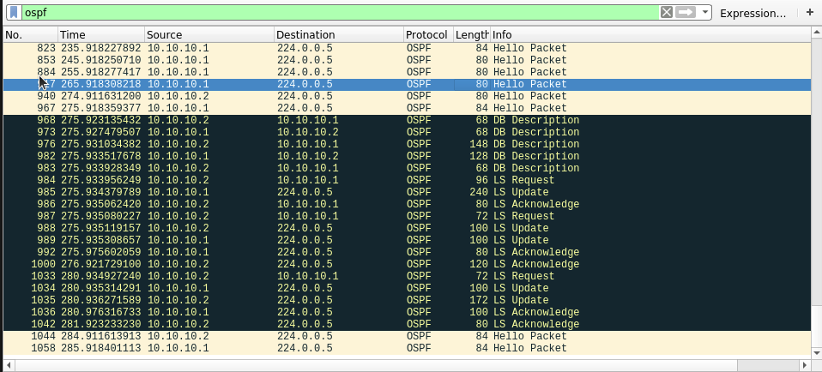

Submissions

[20 points] Screenshot configurations of R1, R2, R3, and R4

R1

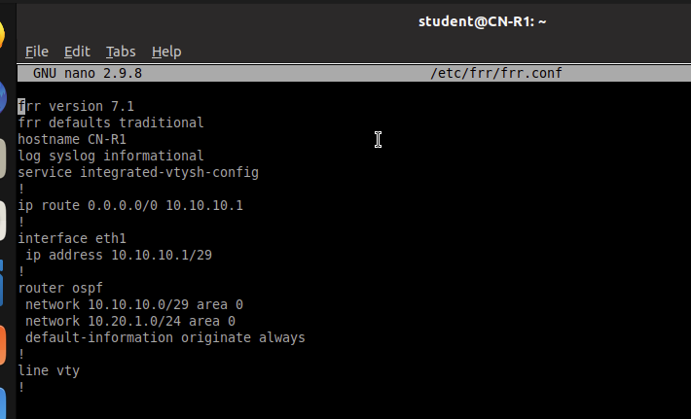

R2

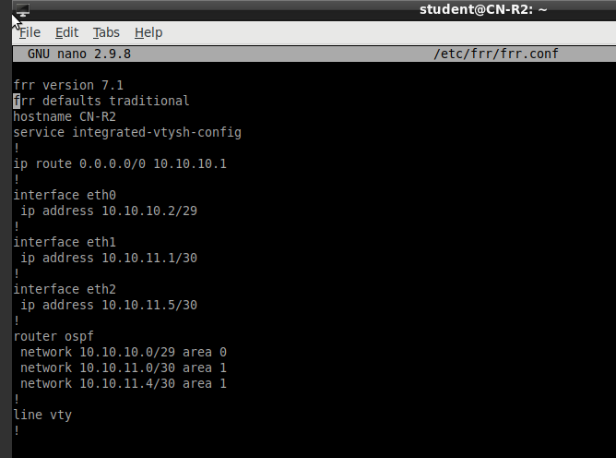

R3

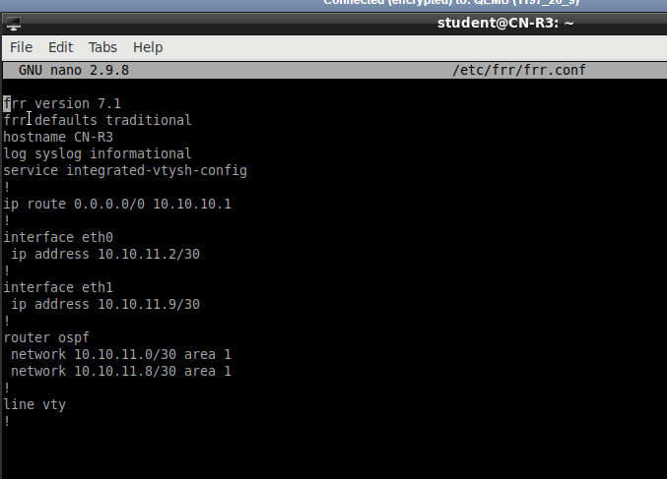

R4

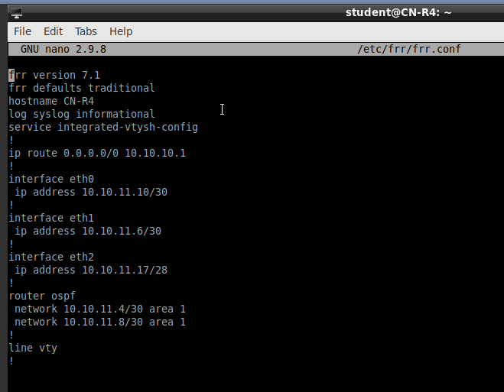

[10 points] ICMP results from R3 to R1

R1’s Wireshark

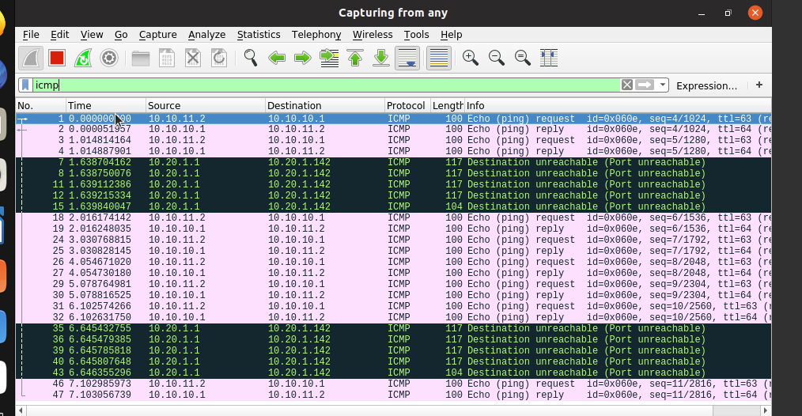

R3’s Wireshark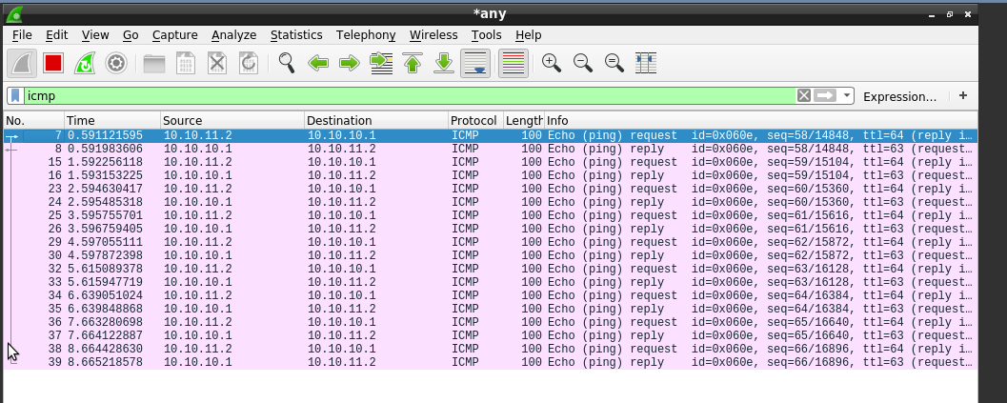

Because R2 is the area-border router, it has to be turned on so that R3 and R1 can send ICMP messages between each other.

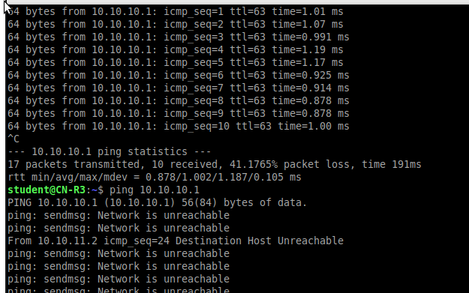

Turning off R2 will create a Network is unreachable message.

[10 points] Wireshark screenshots on R1



[10 points] Screenshots depicting successful ping requests to the SFTP server (128.238.77.36) from R1, R2, R3, and R4

R2

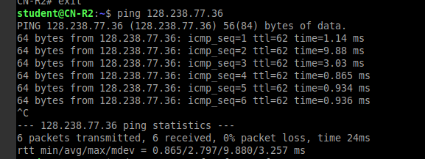

R3

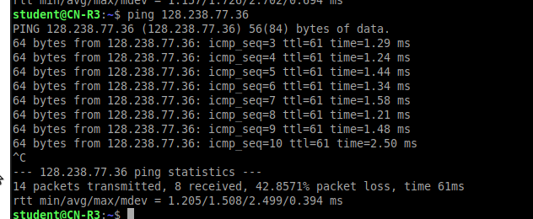

R4

\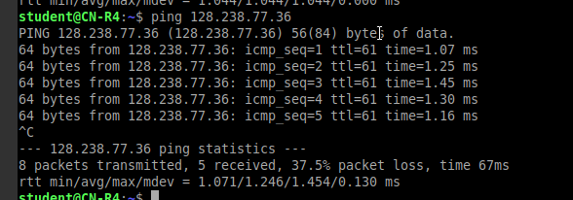

[50 points] Answers to questions 5a-5c Please remember to submit your lab results as a single PDF document. While you may work in groups, you MUST submit your own work.

1. https://networkengineering.stackexchange.com/questions/46745/ospf-link-state-advertisement